Mixing water

Two cups each contain the same amount of water.
One cup is poured into the other.

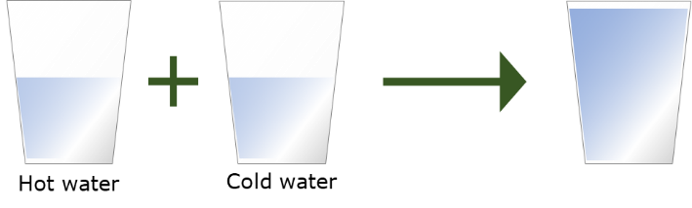
1.

What will the water feel like when it is mixed?
Put a tick (✓) in the box next to the best answer.
A | Hot
B | Warm
C | Cold
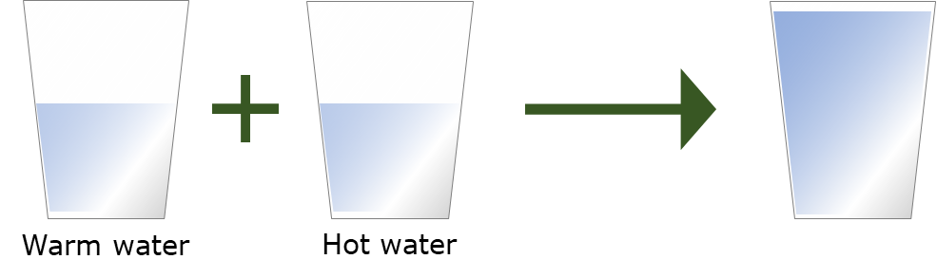
2.

What will the water feel like when it is mixed?
Put a tick (✓) in the box next to the best answer.
A | Warm
B | Very warm (nearly hot)
C | Hot
D | Very hot

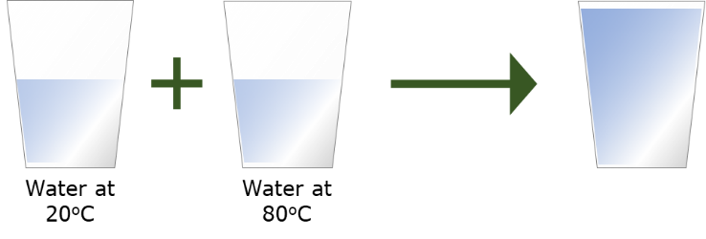
3.

What temperature will the water be when it is mixed?
Put a tick (✓) in the box next to the best answer.
A | 50 ºC
B | 60 ºC
C | 80 ºC
D | 100 ºC

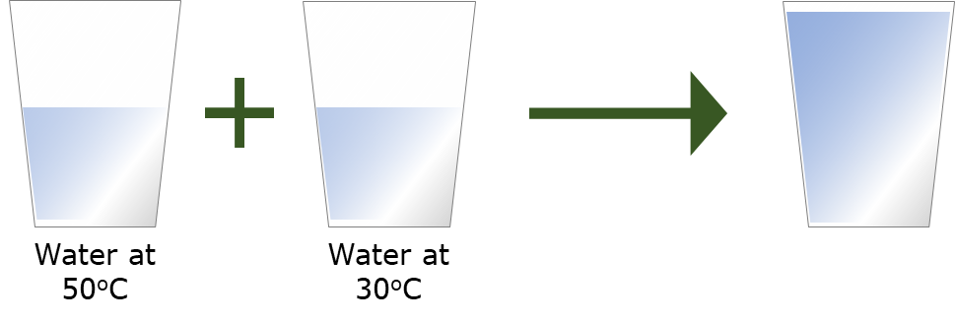
4.

What temperature will the water be when it is mixed?
Put a tick (✓) in the box next to the best answer.
A | 20 ºC
B | 40 ºC
C | 50 ºC
D | 80 ºC

Physics > Big idea PMA: Matter > Topic PMA1: Heating and cooling > Key concept PMA1.2: Heating and cooling
Diagnostic question
Mixing water

Overview
Learning focus: | If two objects at different temperatures are in contact, energy will move spontaneously from the object at the higher temperature to the object at the lower temperature.
Observable learning outcome: | Make qualitative predictions about the resulting temperature when hot and cold water are mixed.  P  Make quantitative predictions about the resulting temperature when hot and cold water are mixed
Question type: | Simple multiple choice
Key words: | Temperature

P | PRIOR UNDERSTANDING  This diagnostic question probes understanding of ideas that are usually taught at age 5-11, to aid transition from earlier stages of learning.

What does the research say?
Students are usually good at predicting that when samples of hot and cold water are mixed, the temperature of the mixture is somewhere in the middle. When samples are mixed students need to use the idea that temperature is an intensive property in order to predict that the resulting temperature. Some students are likely to get this wrong because they confuse temperature with an amount of energy and adding more water adds more energy. When a value for the temperature of each sample is given some students add or subtract the temperatures, applying a mathematical process without appearing to think about what happens (Erickson and Tiberghien, 1985; Driver et al., 1994; Millar, 2011).
Ways to use this question
Students should complete the question individually. This could be a pencil and paper exercise, or you could use an electronic ‘voting system’ or mini white boards and the PowerPoint presentation.
The answers to the question will show you whether students understood the concept sufficiently well to apply it correctly.
If there is a range of answers, you may choose to respond through structured class discussion. Ask one student to explain why they gave the answer they did; ask another student to explain why they agree with them; ask another to explain why they disagree, and so on. This sort of discussion gives students the opportunity to explore their thinking and for you to really understand their learning needs.

Differentiation
You may choose to read the questions to the class, so that everyone can focus on the science. In some situations it may be more appropriate for a teaching assistant to read for one or two students.
Equipment
For the class (optional):
- Three 250 cm³ beakers
- Three 0-100 ºC thermometers
- Kettle
Expected answers
1. B (warm)
2. B (very warm – nearly hot)
3. A (50 ºC)
4. B (40 ºC)
How to respond - what next?
Most students are likely to answer Q 1 and 2 correctly because they match common experience. Students who answer Q 1 wrong are more likely to say the mixed water is hot (A) and those who answer Q 2 wrong are more likely to say the mixed water is hot (C) or very hot (D). These answers show students are treating temperature as a quantity contained in each cup that accumulates as more water is added.
In Q3 60ºC and 100ºC are obtained by adding or subtracting the temperatures of the initial samples. Students giving these answers are likely to be applying familiar mathematics without thinking through what is really happening. 100ºC may also suggest an additive approach to temperature. Students giving answer C may consider the ‘strongest’ temperature to have ‘won’.
Q4 has similar distractors as Q3 with 20ºC and 80ºC obtained by random mathematics.
If students have misunderstandings about how to work out the temperature obtained by mixing water of different temperatures, it can help to demonstrate what happens. Asking students to predict and explain what they think will happen each time sets up a test that will challenge misunderstandings. Giving students the opportunity to discuss their thoughts in pairs or small groups can help to develop understanding through social construction of ideas.
Acknowledgments
Developed by Peter Fairhurst (UYSEG), from an idea by Stavy and Berkovitz (1980) in Children's Ideas In Science (Erickson and Tiberghien, 1985).
Images: Peter Fairhurst (UYSEG).

References
Driver, R., et al. (1994). Making Sense of Secondary Science: Research into Children's Ideas, London, UK: Routledge.
Erickson, G. and Tiberghien, A. (1985). Heat and Temperature. In Driver, R., Guesne, E. & Tiberghien, A. (eds.) Children's Ideas In Science. Milton Keynes and Philadelphia: Open University Press.
Millar, R. (2011). Energy. In Sang, D. (ed.) Teaching Secondary Physics. London: Hodder Education.
Stavy, R. and Berkovitz, B. (1980). Cognitive conflict as a basis for teaching quantitative aspects of the concept of temperature. Science Education, 64 (5), 679-692.

